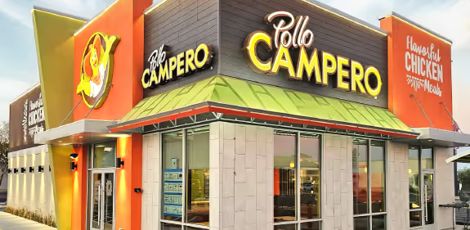

Giving Pollo Campero a secure, modern and innovative Digital Menu Board solution

RFP Response
September, 2026





Proposal to Pollo Campero

We are excited to grow our partnership with Pollo Campero. The Genius software and hardware solutions enable businesses to transform food service experiences and keep guests coming back. Our Genius Digital Menu Board (DMB) solution is an excellent fit to your immediate need.
However, for the future of your business and long-term strategy of vendor consolidation, we believe the combination of Genius + Worldpay gives you the ability to consolidate vendors and bundle capabilities. With our integrated cloud-based platform including point of sale, back office, digital menu signage, kiosk and customer engagement solutions, we strongly believe collaboration with Genius will provide you with not only a best-in-class experience through our Digital Menu Board (DMB) solution, but a roadmap to more vendor consolidation by adopting the rest of our platform where and when it makes operational and economic sense.
We thank you for your time and we welcome the opportunity to share thoughts and cultivate new ideas that will help further differentiate in a crowded marketplace.
Here is what you will find in the enclosed RFP response:
 | Table of Contents
Executive Summary 6
Multiplying What’s Possible 9
Implementation Plan 11
Ongoing Support 18
Pollo Campero Objectives 20
Action Standard 27
Total Genius Solution 37

August 21, 2026

Katherine Celeste Urbina Barillas
Purchasing Specialist
katherine.urbina@somoscmi.com

Dear Katherine Celeste Urbina Barillas,
It is with much enthusiasm that we submit our response to Pollo Campero Digital Menu Boards Request for Information.
Pollo Campero is the destination customers seek for a unique food experience that’s full of life, seasoned with a little zest, and a flavor that’s more than skin deep—that’s bold, complex and a little unexpected. And like Pollo Campero, we too offer bold, complex and unexpected solutions to help you consolidate your vendor stack and remove costs. Global Payments, together with our Genius platform, holds the advantage of combining innovative restaurant technology, payments, and an unmatched international scale under one relationship.
From Digital Menu Boards (DMB) to POS systems, and Kitchen and Back Office solutions, our Genius platform powers businesses from street eats to stadium seats. That’s why we are eager to show how uniquely experienced we are to be your new DMB provider to support all current and future locations. Our solutions are built to be fault-tolerant, both in the physical store locations and in the cloud, to ensure that your restaurants can transact business, prepare, and serve customers without interruption.
It’s this flexibility that can allow you to start with our DMB solution without being required to replace your existing technology, while retaining the ability to consolidate additional capabilities with us over time. A sound flexibility today, consolidation opportunity tomorrow approach allows you the best opportunity to remove costs and innovate your business now and into the future. This enables Pollo Campero to do what you do best, creating great experiences for your customers to come together-intentionally.
As a 42-year veteran of the Enterprise Restaurant business with solutions that meet every restaurant’s technology need and backed by a global payments company for financial stability, we believe we are exceptionally positioned and experienced to meet and exceed Pollo Campero’s business objectives. We work with all our clients to limit business disruption, enhance the customer experience and cost-effectively support operators across all geographies.
Within our responses in the RFP evaluation worksheets, and in the related attachments, we want to instill your trust in the following points of difference:
 | Our experience gives Pollo Campero a trusted partner: Pollo Campero can be confident in knowing Genius is a combination of XPIENT, SICOM, and RTI – three powerhouse companies. Our innovative mindset and practice are rooted in decades of restaurant technology experience. We are very proud of the company we keep, and today we are the technology partner for 17 of QSR Magazine's Top 50 brands.
 | Future Proofing: Our cloud-based solutions are built to be nimble. We can naturally adapt and innovate with Pollo Campero partners as the technology environment and consumer expectations evolve. With Genius as your cloud Digital Menu Board partner, Pollo Campero will be “Future Proofed.”
 | Scale & Reach: Pollo Campero will join more than 51,000 restaurants and 110,000 merchants in over 62 countries worldwide that choose our purpose-built technology solutions to help deliver positive customer experiences. Genius leverages Global Payments’ reach across the globe to support your global infrastructure requirements and deliver best-in-class services to franchisors and franchisees.
 | No Rip & Replace: Genius is experienced to support and service fast-growing franchise partner communities, having tailored our approach for the unique standards and timelines of tens of thousands of operators all while minimizing impact to restaurants operators.
 | Low Cost of Ownership: With the idea of flexibility today, consolidation opportunity tomorrow, your Genius journey can start with DMB but then evolve over time and your needs to other components like payments, back office and others. This allows you the flexibility to generate cost savings over time by consolidating services under one vendor, instead of many.
Global Payments welcomes the opportunity to begin our partnership with Pollo Campero and modernize how your customers experience the brand with enhanced in-store technology.
We appreciate your time and consideration and look forward to presenting how Genius can serve as a reliable, long-term technology foundation for Pollo Campero restaurant operations now and in the years ahead.
Sincerely,
 |  | Todd Vahlsing
Michael Schwartz  VP, Enterprise Sales | Tracy Gallimore  SVP, Enterprise Sales | Todd Vahlsing  Sales Executive

A global powerhouse today

$9.15B
Adjusted net
revenue
27,000+
Team members
worldwide
6M+
Merchant
locations
Fortune®
500
company
Physical presence
38
countries
Operating in
175+
countries
3.5M+
Orders processed
per day
94B+
Transactions
per year

Executive Summary

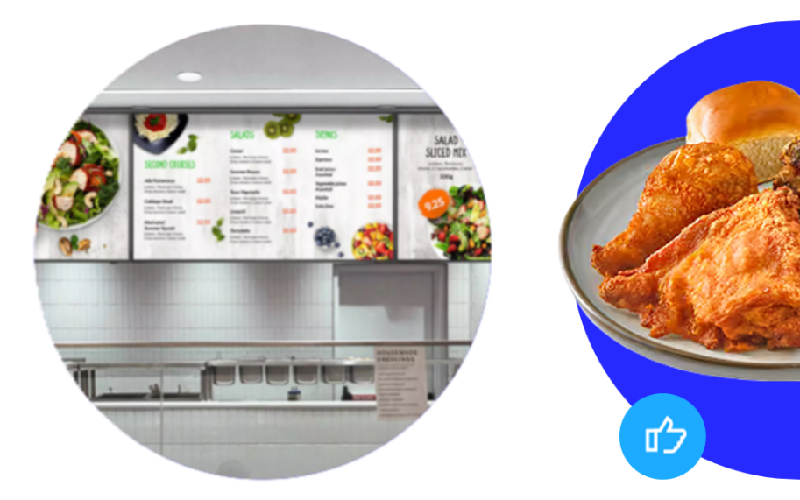
Genius Digital Menu Boards

Genius Digital Menu Board allows you to update pricing, promotions and menu content in real-time across indoor, outdoor, pre-sell and confirmation displays. It’s directly integrated with POS and pricing tools, ensuring consistency and agility in QSR, fast casual and cafes.
But furthermore, DMB is just one component of a full stack of technology designed for the QSR space. Rather than adding another standalone vendor to the mix, add a capability to a partnership that can grow with Pollo Campero.
Genius can solve the immediate DMB requirement, integrate with your existing environment, support your domestic and international growth, and give you the option to consolidate restaurant technology and payments over time, where doing so reduces complexity and creates better economics.
Key benefits include:
- Boosted customer order size Guests spend more when influenced by dynamic menus.
- Real-time remote updates Instantly update prices, specials or sold-out items with centralized control across multiple locations.
- Customization Tailor menu boards by time, location and guests.
- Highlight promos Spotlight seasonal and high-margin items, promote combo deals, loyalty programs and more.
- Durability Provides commercial-grade displays built for long hours and different environments.
- Immersive and mighty Our indoor electronic menu boards set the standard with vivid, realistic picture quality and HD resolution, and a thin bezel size and screen thickness for a sleek look.
Genius Digital Menu Board software is built for ease and speed. It features a no-code, drag-and-drop interface that allows operators to update menu items, pricing, images and promotions without needing technical support. The intuitive UI enables quick scheduling of the menu. Whether you’re managing one location or hundreds, the experience is designed to be fast, scalable and user-friendly for busy teams.

The Winning Formula for Pollo Campero
Genius gives Pollo Campero a strong solution for your DMB requirements while creating a foundation for broader vendor consolidation, integrated restaurant technology and payments and international growth over time.
Our DMB solutions, developed, deployed and supported by Global Payments provide:
- Multiple solutions for both immediate, mid-term, and long-term needs.
- The technical know-how to work around-the-clock to solve for different scenarios.
- The deepest support of people across a breadth of functions to develop solutions for Pollo Campero.
- Our solutions are built on an open API architecture that supports integrations with many different third-parties for both pricing and OCU integrations. This affords us some flexibility to work with impactful, existing third-parties like Oracle and NCR.

Additional capabilities that make Genius a “fit” for Pollo Campero
- In-House, seasoned Project Management resources.
- Proven ability to scale rollouts - domestically and internationally.
- Network of certified installation technicians.

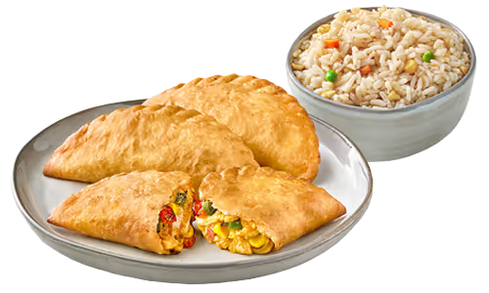
- Integrated with leading delivery providers and 100’s of other service partners.

- Warehouses with staging, shipping, depot, kitting, etc. across U.S./Canada.
- Hardware “Break/Fix” support.
- 24/7/365 technical support.

Multiplying What’s Possible


Bringing more value to Pollo Campero
Global Payments and Worldpay have joined forces. This means broader capabilities, greater reach, accelerated innovation and more expertise to support merchants and partners at every stage of their growth. Explicitly for you, this provides access to innovative restaurant technology, powerful payments abilities, broader commercial scale and international capabilities through one strategic relationship. The solutions and services we're known for aren't going anywhere. And now it provides a worthy incentive to consolidate your vendors to one, meeting one of your corporate objectives.

Global Payments is joining forces with Worldpay, multiplying what’s possible for our clients and partners by focusing our resources toward a single vision — to ignite business growth and enrich lives around the world.
Our combined capabilities and capacity allow us to deliver more products and services to merchants of all sizes across the globe. In an industry where scale and distribution capabilities matter more than ever, we are well positioned for growth opportunities.
Our combined talent has the innovative spirit and expertise to anticipate what our clients need, and we are putting all our energy and expertise into building feature-rich products and distinctive service experiences.
Importantly, the products clients rely on, including flagship solutions like Genius and Worldpay’s ecommerce capabilities, are now even better together.

Acquiring via
Worldpay provides payment processing services across all US states through licensing agreements with Mastercard, Visa, and Interac. Our platform seamlessly handles both Card Present (CP) and Card Not Present (CNP) transactions, ensuring reliable and secure payment solutions for a wide range of business needs. In addition to VISA, Mastercard, AMEX, JCB and Interac, Worldpay also supports digital wallets.






Scope of Work Responses
Scope of Work Responses
Project Kickoff
Conduct kickoff; confirm governance, roles, project plan, timeline, communications, risks and dependencies.
Our Implementation Plan for Pollo Campero
On the following pages, we have framed an implementation plan for your review and consideration. This plan includes the following elements:
- Expected Dependencies
- Key Success Factors
- Technical Roadmap
- Working Together
- Support Plan
- Price Proposal
Additionally, after understanding your strategic goals and tactical needs, we believe we are uniquely positioned and experienced to bring this concept to reality—from Lab to Pilot to Roll-Out.
We look forward to working closely with you to review and refine this implementation plan.
Expected Dependencies for Pollo Campero
 | Clear Scope Definition  - Initial pilot objectives  - Key success factors  - Menu and branding
 | Integration Considerations  - Payments  - Kiosk  - Loyalty & CRM  - Mobile Ordering & Delivery
 | Configuration & Menu Information  - Menu set-up & finalization  - Lab work and feedback with ops
 | Dedicated Resources  - Identify key team members from Pollo Campero and from Genius to be dedicated to the project
 | Other Dependencies  - Master Services Agreement
Key Success Factors for Pollo Campero
Success on the planning and execution of Pollo Campero solution will be driven by the establishment of a clear work breakdown structure, documented requirements/gaps for Pilot, a shared lab environment, an operational readiness plan, detailed pilot plans, and an overall program governance model.

 | Program Governance & Team Structure  - Executive steering committee established to drive overall vision, direction, and decision making  - Leadership team built to manage execution of the project plan and provide clear issue and change management  - Project managers and functional team leads assigned to develop and implement a documented project plan and to report regularly on status, issues, and risks
 | Pilot Requirements  - Discovery & Feedback  - Development & Integration Priority Mapping  - Delivery Schedule
 | Shared Lab  - Success criteria  - UAT Support  - Customized Pollo Campero Configuration Management  - POC Development / Testing
 | Operational Readiness Plan  - Equipment Ordering / Installation  - Employee Training & Knowledge Base  - Customer Support & IT System Monitoring  - Professional Services  - Staff Readiness
The most important success factors for Genius and our parent company Global Payments are the people and processes that we put in place to deliver a consistently top-notch boarding experience.
For Pollo Campero, we would assemble our A-Team to ensure milestone delivery while remaining flexible to incorporate learnings as they emerge.
Onboarding Milestone Activities & Cross Functional Owners
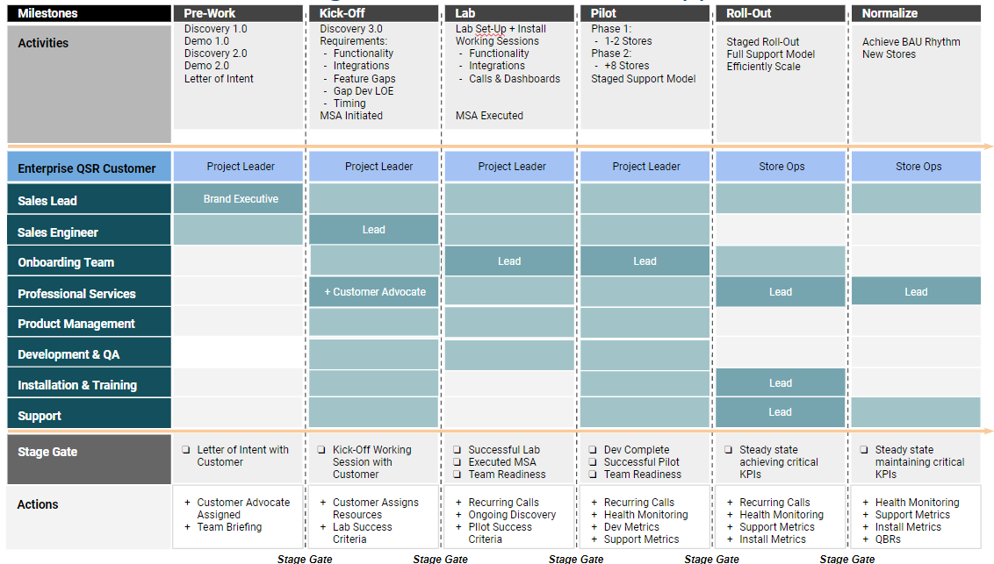
Technical Roadmap for Pollo Campero
We pride ourselves on designing client-centric project teams to work collaboratively and transparently in delivering required solutions on time and on budget. Our goal is simple: To keep our commitments while delighting Pollo Campero during the initial stages and at full scale.
Discover Phase
- Requirement Identification: Facilitate IT & Operations deep-drive reviews based on program scope & requirements.
- Timeline: Define project timeline and key dependencies based on development needs and Pollo Campero deployment goals for the project.
- Onboarding: Assign a technical project leader to ensure milestone delivery, acceptance testing and full implementation.
Lab Phase (Current Genius Solutions)
- Functional Gaps: Those not identified during Discovery.
- Integrations: Stand up integrations - ex: NCR, Oracle, etc.
Pre-Pilot Phase
- Operational and Real Estate: Working with the Pollo Campero team to identify key locations and footprints to identify where key activities need to be located.
- IT Inputs: Define networking requirements.
- Hardware: Assemble key hardware component list and determine if any hardware customization is needed.
- Installation: Define an installation playbook with procedures and quality checkpoints to ensure locations are ready to open and begin transacting business.
Pilot Phase
- Installation of initial deployments.
- Onboarding team members will be onsite for deployment throughout go-live watching operations, training, and troubleshooting any areas that need to be addressed to ensure the first location operational.
- Record broad feedback and ensure that the next installs and stores consider the benefits of our initial learnings.
Market Phase
- Installing in 5-20 locations
- Validating different operating and deployment models
- Perfecting configurations, fixing bugs
- Build out key training guides and ensure scalability of roll out plans
- Validate stability to ensure infrequent issues do not show up as scale is achieved
Rollout Phase
- Operationalize roll outs
- Build out key procedures for new location openings
- Convert any already existing locations (if applicable)
- Standardize remaining training
- Ensure support model matches operations
- Monitor and iterate
Careful coordination and project management will be critical to our success. The preliminary, high-level roadmap below outlines our approach. We have also factored in third-party dependencies as well as any areas where we believe that our solutions allow for accelerated delivery.
Below is a very preliminary timeline for moving the project forward. We look forward to collaborating with you and your team to define a detailed plan of action unique to Pollo Campero goals.

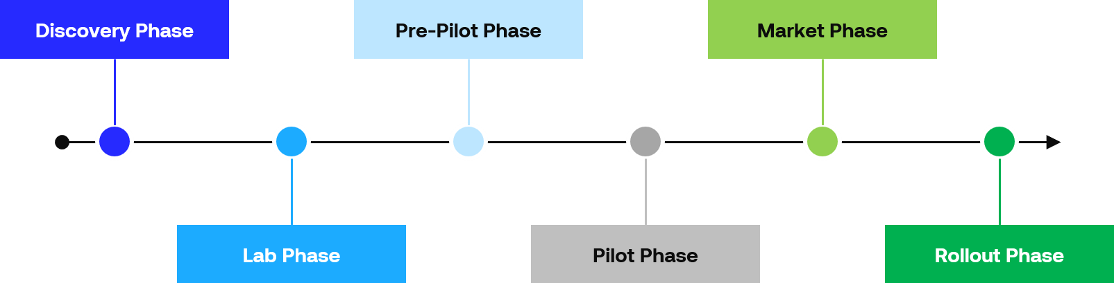

Working Together on Pollo Campero
Our layered Pollo Campero Team will include the engagement of our full leadership team, our technology leaders, our onboarding solution team, our respective product owners, and our support operation.
Our Pollo Campero Team and structure is overviewed below:
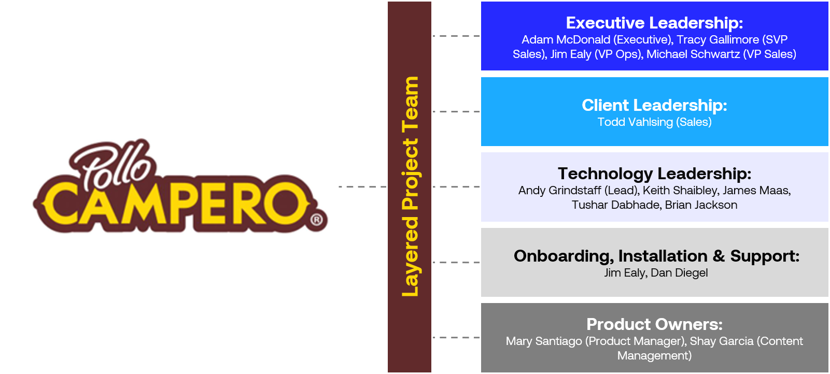
A dedicated Pilot Project Manager (PPM) will be assigned to Pollo Campero. The PPM’s project team will work closely with all teams to establish the processes and procedures for a successful deployment. The PPM will have a direct line to the product and development teams supporting the process, and immediate access to senior management if needed. Seamless, warm transition between your Pilot Project Team and your supporting Project Management Team will occur once all parties are ready to move from Pilot to Production status.
Throughout our relationship, Genius’ leadership will be engaged to ensure success.
Site Surveys
Describe and price the site-survey process for existing and new restaurants, including mounting, electrical, network, sight lines and environmental conditions.
Yes. Each location deployment begins with a kickoff email/meeting with restaurant stakeholders, during which the site survey is scheduled. During this kick-off, all the information needed for the assessment will be communicated by the Genius team, like: number, type, and location of devices, electrical architecture of the site, environmental conditions inside and out, sight lines, and more.
Each location should have a site survey so the Genius team members can understand its operations and use cases. The site survey also generates the initial hardware recommendations for the restaurant team to review.
Compatibility Assessment
Indicate whether the proposed solution can reuse or adapt to existing equipment or whether new equipment is required. Identify assumptions and site validation needed.
Yes. Genius can generally support the reuse of Pollo Campero’s existing digital menu board displays, subject to verification of the installed equipment and its remaining useful life. In many cases, new display hardware is not required.
As part of the discovery and site assessment process, Genius will evaluate the manufacturer, model number, age, condition, and capabilities of the existing displays to determine the most appropriate deployment architecture and recommend the best long-term solution. Depending on the equipment and its expected lifespan, existing displays may be reused with a Genius media player/controller or, where supported, through a controllerless deployment model.
To assess compatibility, we would request details regarding the make and model of the displays, as well as any additional information needed to validate connectivity, mounting, power requirements, network infrastructure, and overall system compatibility. Based on this assessment, Genius will identify which components can be retained and provide recommendations that balance reliability, performance, and total cost of ownership.
In scenarios where existing displays are not natively supported for controllerless deployment, Genius can provide a controller-based solution that maximizes the value of the current display investment. Our media player architecture supports dual-display output, enabling a single device to power two menu board displays. This approach can significantly reduce hardware, installation, and ongoing support costs compared to deploying a dedicated player for each screen, while still delivering a fully featured digital menu board experience.
This flexible deployment model allows Pollo Campero to leverage existing assets wherever practical, minimize capital expenditures, and maintain a scalable foundation for future growth and technology enhancements.
Customer-Owned Stream Inventory
Review the existing equipment and components stored at our warehouse and describe the proposed approach for evaluating and incorporating compatible items into the project. Identify compatibility requirements, inspection or testing needs, installation costs, warranty and support limitations, and any items that cannot be used. The detailed inventory list will be provided when available.
Yes. Genius can add a step in the site survey process mentioned above to accomplish this.
Indoor Digital Menu Boards
Address the typical configuration of five screens per location: four 42-inch landscape and one 47-inch portrait. Current equipment is a mix of Samsung and LG. Supply new equipment only where required.
Hardware Configuration Architecture
Genius DMB Set-up for Indoor with Redundancy (non-SOC)
NOTE: Utilizing existing displays; the Genius DMB application runs on the Genius media controllers.

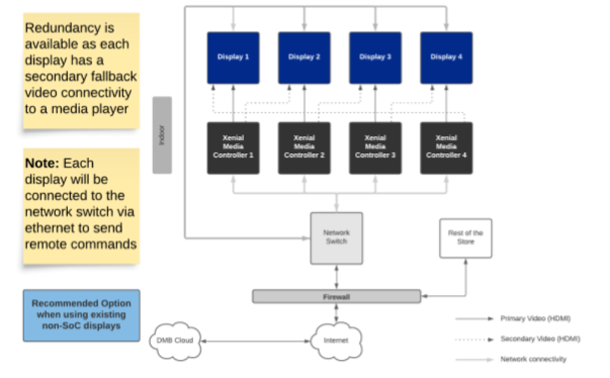

Genius DMB SoC* Set-up for Indoor
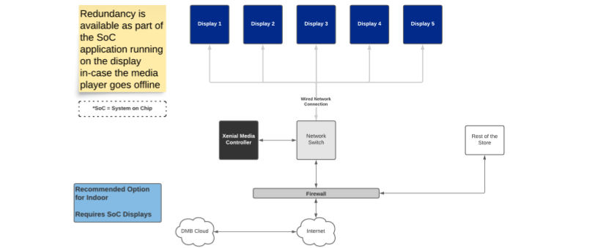
NOTE: The Genius DMB application runs on the SoC displays (LG-WebOS or Samsung TizenOS 2.4) managed by the Genius media controller application.

Digital Menu Board Media Player Specs
MP30 Equipment Specifications

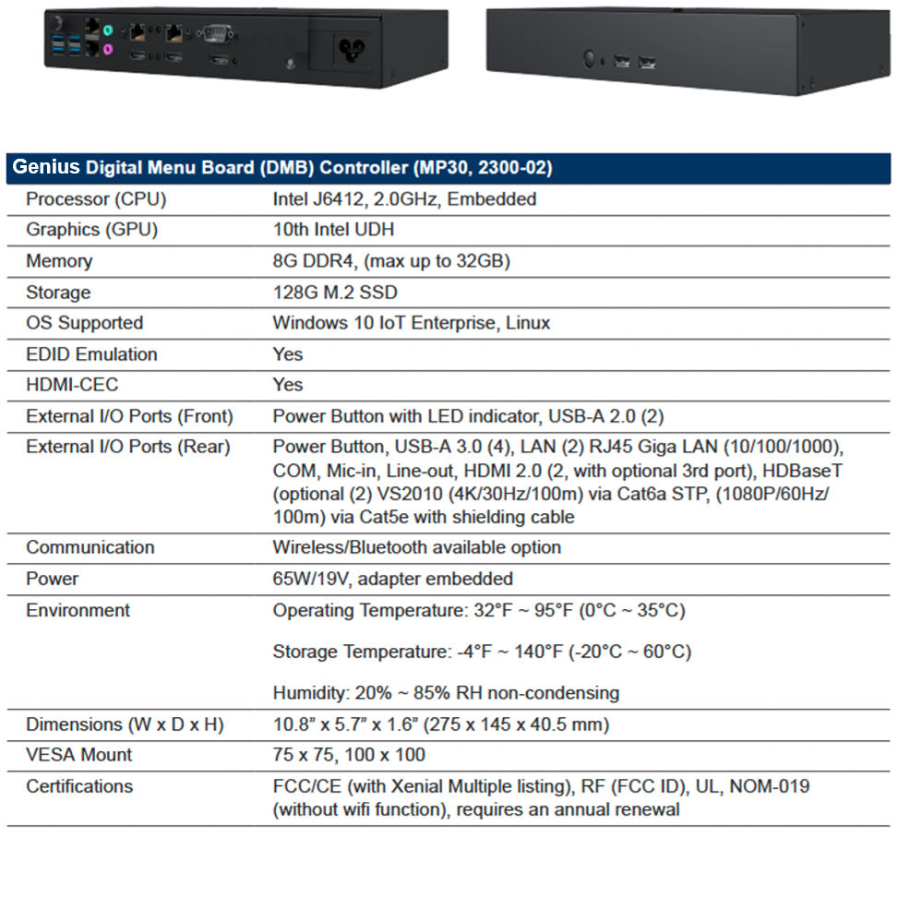

LG TV Specs / Indoor
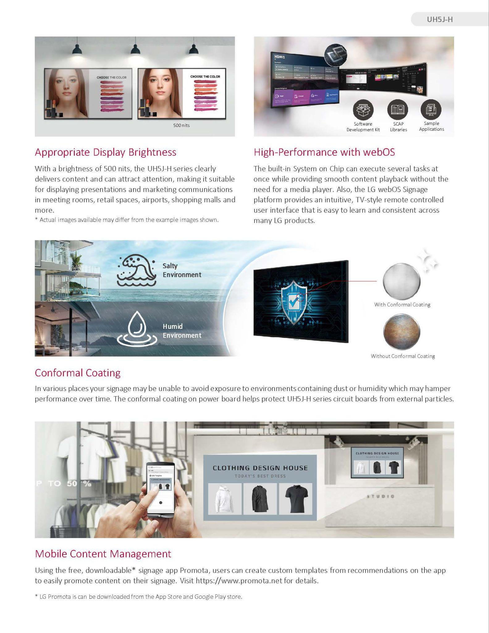

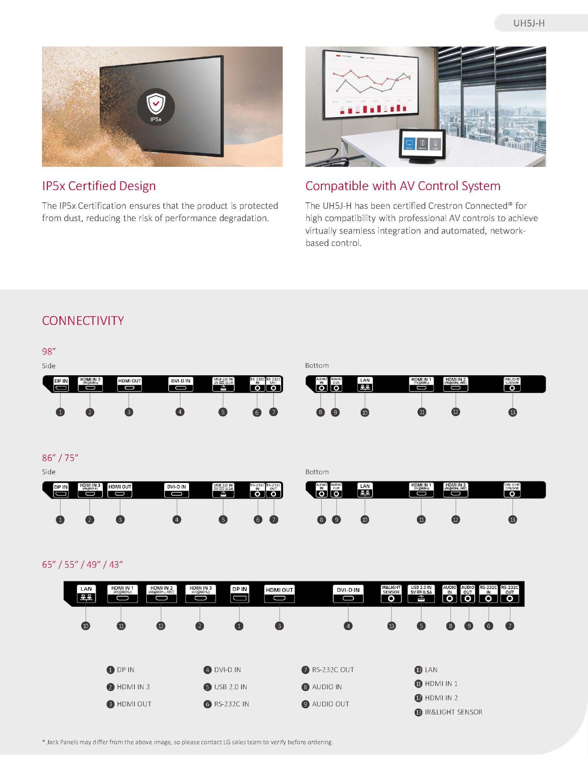

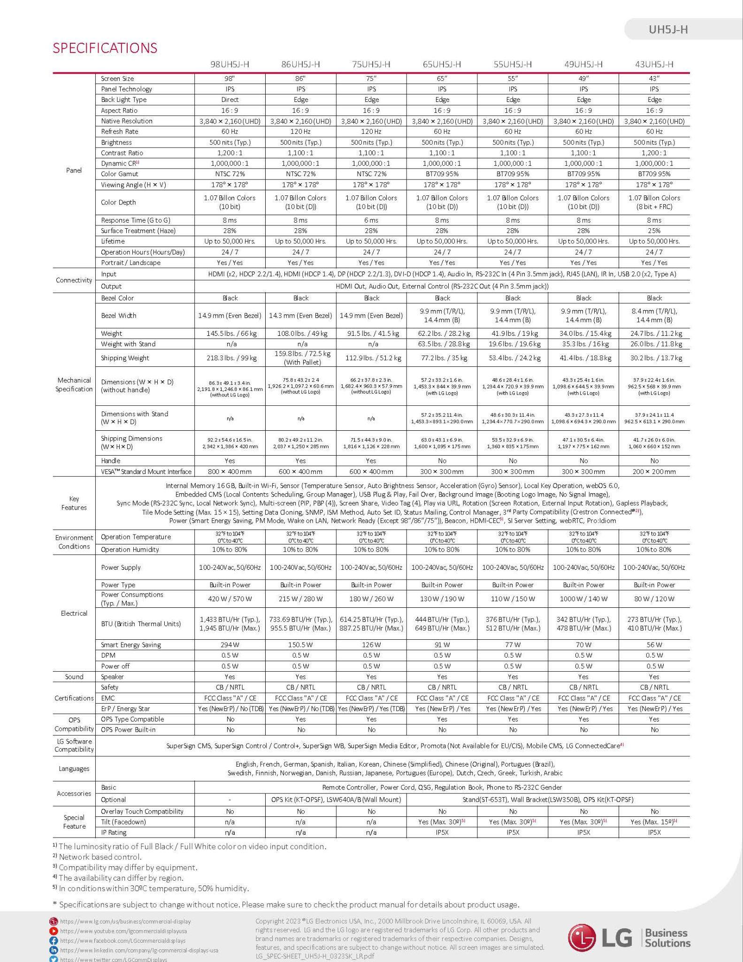

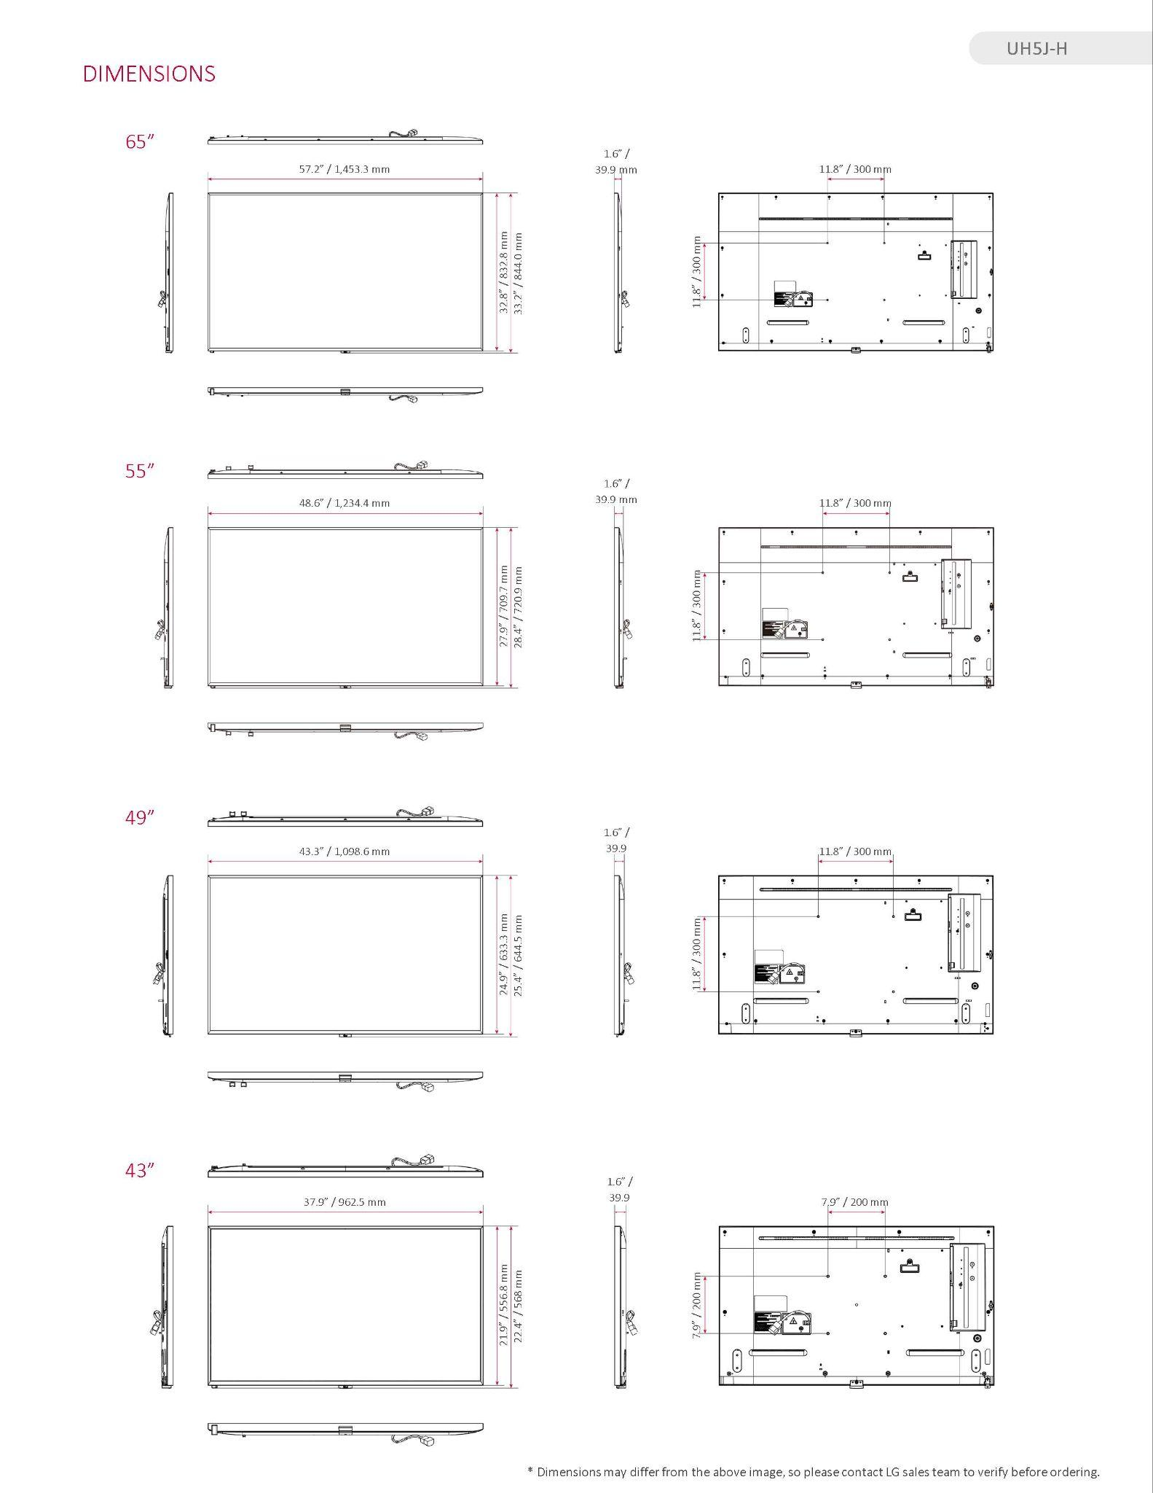

Outdoor Digital Menu Boards
Address 55-inch LG screens: three or four at typical locations depending on presell, and six at dual-lane locations. Most locations have a canopy and presell board; configurations vary.
Genius DMB Controllerless SoC Set-up for Indoor and Outdoor
NOTE: The Genius DMB application runs natively on the SoC displays (LG-WebOS).

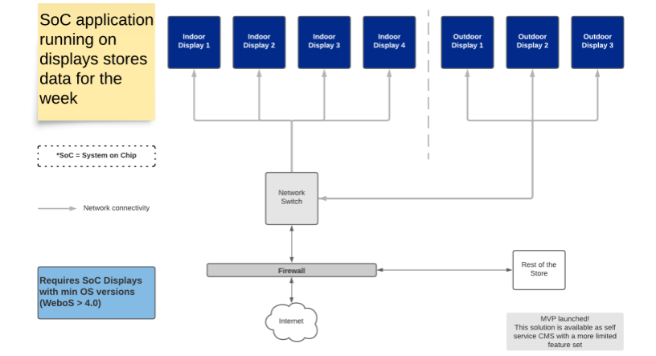

Order Confirmation
Provide order confirmation directly on the drive-thru menu screen and integrate it with the POS. Speakers and microphones are out of scope.
Yes. Our Genius DMB platform supports flexible POS integration via a robust API architecture, enabling real-time order confirmation, menu, and pricing synchronization, as well as AI ordering integrations. We have integrated with QSR POS systems including PAR Brink, Lucas POS, and QU POS.
POS integration is fully optional. Our DMB solution can operate independently with built-in tools for managing menu and pricing content without POS connectivity.

Cloud CMS
Provide centralized cloud CMS for content, pricing, promotions, dayparting, scheduling, user access, device monitoring and reporting.
Yes. The Genius platform provides a fully centralized, enterprise-grade CMS designed to support the complete lifecycle of menu board content management across all domestic restaurant locations. Within a single interface, authorized users can create, manage, schedule, publish, and roll back content using intuitive content layout tools and streamlined deployment workflows built into the native CMS.
Content creation is powered by flexible layout templates and dynamic publishing tools, while scheduling capabilities enable precise control over when and where content is displayed. The platform’s deployment engine ensures reliable distribution of content to all assigned locations, and built-in rollback functionality allows users to quickly revert to prior versions if needed—ensuring operational continuity and minimizing risk.
In addition, Genius offers managed services options for organizations that require additional support. Our team can assist with or fully manage content operations on behalf of Wingstop, including content updates, scheduling, and deployment execution. This provides scalability and ensures consistent, high-quality content delivery even during periods of limited internal bandwidth or increased demand.
Together, these capabilities deliver a centralized, scalable, and reliable solution for menu board content management across the entire restaurant network.
Managed Menu Content Services
Describe and price the vendor-managed content services for menu boards, including menu image updates, price changes, promotional updates, content scheduling, quality assurance and publishing. Explain the process for submitting, reviewing and approving requests; available communication channels; standard and emergency turnaround times and service levels; escalation procedures; included update volumes; and any additional fees for creative services, urgent requests, requests exceeding the included volume or ongoing content management. Clearly indicate the applicable fee type and pricing basis.
Content Services Workflow/ Delivery SLA
Content Management: Deployment Timelines
3 | 10 | 15
Business Days  Small Updates | Business Days  Medium Updates | Business Days  Large Updates
Examples  - Disabling a franchisee configurable item in the portal  - 2 panels of content being modified (x 3 variations) = 6  - 10 static changes per panel | Examples  - 1 full panel rebuild (move/change pricing, move/change artwork, animations, build all variations (landscape, landscape 2/3, landscape ½, drive thru, vertical, vertical1/2)) OR…  - 5 panels of content being modified (x 3 variations) = 15 panels  - 1 timed event with opt-in period  - 10 static changes per panel | Examples  - 2 full panel rebuilds (move/change pricing, move/change artwork, animations, build all variations (landscape, landscape 2/3, landscape ½, drive thru, vertical, vertical1/2)) OR…  - 1 coordinated content release

Workflow with Brand Partners & Vendors
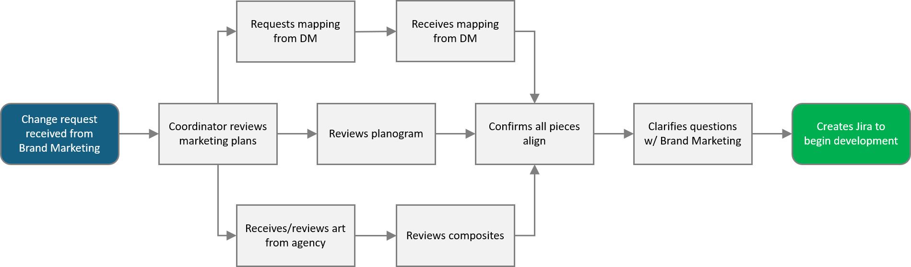

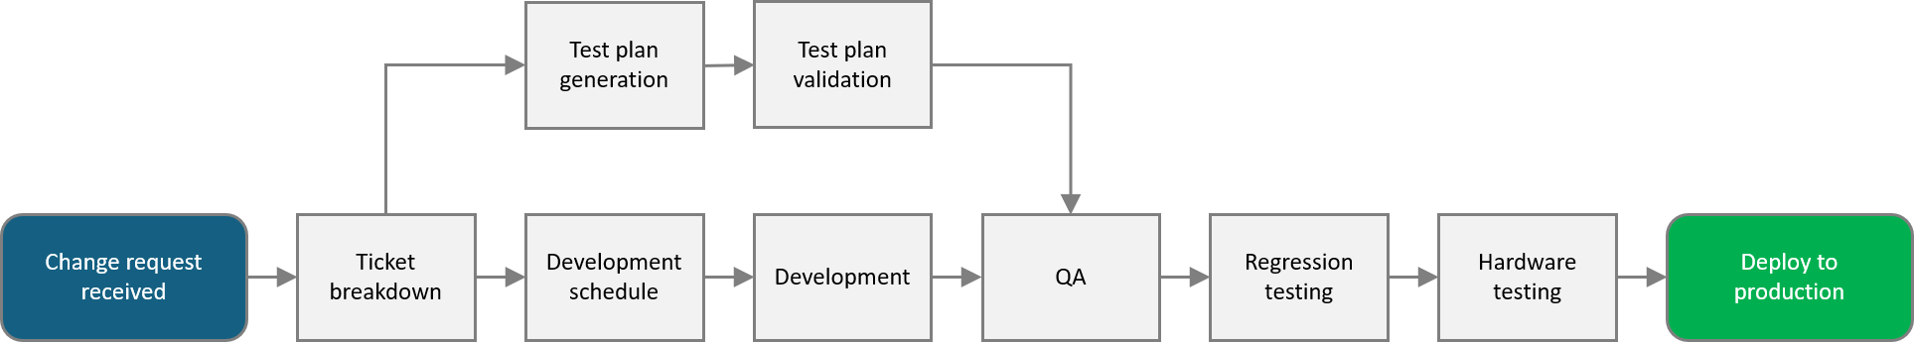
Content Intake and Delivery Process

Oracle & NCR POS Integration
Integrate with Oracle and NCR POS for pricing, item availability and order-confirmation requirements. State interfaces, dependencies, testing and support.
Yes. Genius DMB has completed an NCR Cloud to Genius Cloud pricing integration. This data then flows from the Genius Cloud to the instore GDMB devices, keeping the POS and DMB constantly in sync.
As for Oracle, our platform supports flexible POS integration via a robust API architecture, enabling real-time order confirmation, menu, and pricing synchronization, as well as AI ordering integrations. We have integrated with QSR POS systems including PAR Brink, Lucas POS, and QU POS. We can develop a POS integration for Oracle too.
Installation & Commissioning
Manage staging, installation, testing, cutover, content/POS validation, commissioning and site sign-off while minimizing restaurant disruption.
Yes. Genius can manage end-to-end installation for Genius Digital Menu Boards deployments, including coordinating pre-install activities, scheduling, and on-site execution to help limit restaurant downtime and disruption. Our team of installation experts can work with Pollo Campero’s construction, facilities, and operations teams to minimize disruption to restaurant operations, using our standard Operational Readiness Plan shown above:
- Equipment Ordering / Installation
- Employee Training & Knowledge Base
- Customer Support & IT System Monitoring
- Professional Services
- Staff Readiness
Equipment Removal
Remove equipment from closing or refreshed locations and coordinate with Pollo Campero Facilities and IT.
Yes. Equipment removal is not a standard provided service. However, if it is required, we could work out de-installation plan with the appropriate costs.
Storage & Inventory
Tag, inventory, condition-grade and store removed hardware at the vendor facility; provide inventory reporting.
Yes. Like the equipment removal requirement. Storage and inventory is not a standard provided service. However, if it is required we could work out de-installation plan with the appropriate costs.
Redeployment
Test, prepare, ship and redeploy stored equipment to another location when authorized.
[SRW: So, I’m assuming they mean all their old hardware. Do we do that for hardware that isn’t ours?]
Administrator & Field Training
Provide CMS and operational training, guides and knowledge transfer for corporate administrators and applicable field users.
Yes. We offer demonstrations and virtual training formats and will work closely with your teams to ensure a thorough knowledge transfer. We look forward to discussions regarding on-site training support.
- Self-serve training can be launched directly from within the software. Instructor-led training is available as needed, depending on the subject matter.
- Genius Academy (our LMS) is provided at no cost and tracks completed training and certifications. We build curricula to certify learning groups on necessary functions and features.
- Training materials include video links and documentation links to specific topics. We also provide user guides and other training content which can be made available on your LMS portal/platform.
- Post-implementation training from our Product Education Team works with business leaders and subject matter experts to scope the need, design instruction, create the learning schedule, determine the assessment process, and evaluate the materials.
Support & Maintenance
Provide help desk, SLAs, remote diagnostics, monitoring, escalation, field service and hardware-replacement protocols.
Yes. Genius supports ongoing operations with documented incident plans, defined escalation paths, and proactive monitoring and alerting for the Genius platform.
For critical issues, the Genius Support Team follows documented plans covering internal escalation and customer notifications; when a possible Sev1 event is detected (via automated alerts or increased case volume), it is escalated to DevOps, Production Support, and R&D, a Sev1 bridge line is opened for remediation, and customer notifications are sent as agreed with the customer.
Detection, escalation, and communications are supported by configurable near-real-time alerts (SMS, email, and programmatic events) across Sales/Operational Events, Payroll, Hosting/Cloud Operations, and 3rd Party Integrations. Monitoring integrates with enterprise tools including LogicMonitor, ElasticSearch (log alerting & APM), and vendor-specific tools, with automated routing across 1st-, 2nd-, 3rd-level, and engineering teams based on severity. During severe problems, outage notifications are sent to clients, and external Slack channels are used for real-time communication.
Our customers typically chose incident SLAs for response time and resolutions times based on their business needs. We can also customize them, to provide faster times during live events. Our typical Support SLAs include a 90 second Average Speed of Answer (ASA) and a 5% Abandon Call Rate. While we work with each client to determine the best support model, below is an example of common SLAs.
During Live Event
- Priority 1: Issue that causes a severe operational impact to the location/stand [Response - 15 minutes; Resolution - 90 minutes].
- Priority 2: Issue that causes a significant impact to location/stand [Response - 30 minutes; Resolution - 2 hours].
Standard
- Priority 1: Issue that causes a severe operational impact to the location/stand [Response - 1 hour; Resolution - 4 hours].
- Priority 2: Issue that causes a significant impact to the location/stand [Response - 2 hours; Resolution - 8 hours].
- Priority 3: Issue that causes minor/no impact to the location/stand [Response - 4 hours; Resolution - 24 hours].
- Priority 4: Other / Customer Inquiries [Response - 12 hours; Resolution - 48 hours].
For additional information, please refer to the Ongoing Support section of our Executive Summary above.
Hardware & Software Warranty
State coverage periods, inclusions, exclusions, RMA/replacement process and any extended-warranty pricing.
Yes. Our hardware warranty coverage is 3 years for all hardware/devices included in pricing/hardware quotes. Hardware continues to be supported after the warranty period; devices outside of warranty have a replacement cost.
In-Store Music
Describe and price separately, including hardware, licensing, implementation and recurring fees.
In-store music is currently not a standard component we offer, but we look forward to further discovery to understand how we can assist with this, or other value-rich components for Pollo Campero.
Guest Wi-Fi
Describe and price separately, including hardware, implementation, management, security and support.
Guest Wi-Fi is currently not a standard component we offer, but we look forward to further discovery to understand how we can assist with this, or other value-rich components for Pollo Campero.
Billing Frequency & Payment Terms
Describe the proposed payment schedule and payment terms, including any advance payment, deposit, milestone billing, invoice timing and payment due dates (e.g., Net 30).
Yes. We can accept NET60 payment terms.

Build Customer Relationships

Every Day.

Michael Schwartz
VP, Enterprise Sales
Michael.Schwartz@globalpay.com

Tracy Gallimore
Senior Vice President of Enterprise Sales
Tracy.Gallimore@globalpay.com

Todd Vahlsing
Sales Executive
Todd.Vahlsing@globalpayments.com

COPYRIGHT
© 2026 Global Payments Inc. All rights reserved. All other products and company names are trademarks or registered trademarks of their respective companies.
LEGAL DISCLAIMER
The contents of this document are the confidential information of Global Payments and its affiliates (collectively, “Global Payments”) and are intended for use by Pollo Campero (WS) exclusively and may not be divulged to any third party without the prior and express written consent of Global Payments.
Care has been taken to ensure the accuracy of this document, but Global Payments does not accept responsibility for any errors or omissions herein, and Global Payments does not warrant the adequacy. accuracy or completeness of the information contained herein.
This document is intended for discussion only and shall not be capable of creating any contractual commitment on the part of Global Payments. Global Payments shall only become contractually bound to Pollo Campero if and when Global Payments and Pollo Campero enter into a formal written agreement signed by Global Payments, creating such contractual commitment.
Global Payments will not be liable for any delays or failures in connection with this document due to the occurrence of any war; act of terrorism; civil disturbance; industrial dispute; strike or blockade; or system, software or equipment corruption or failure; or changes in the relevant central bank or other regulatory bodies' requirements or any other circumstances beyond the control of Global Payments its agents or subcontractors.
CONTRACTING
Global Payments is not entering into any contractual commitments by submitting this bid, nor is Global Payments agreeing to any contractual terms contained in the RFP. All contractual provisions will need to be mutually negotiated between the parties if Global Payments is awarded the bid. Global Payments anticipates negotiating a final definitive agreement based on its standard merchant processing agreement terms and conditions, which will incorporate all needed provisions without need to reference the RFP or related documents.
RESPONSES
Please note that these responses reflect and represent Global Payments' policies and procedures as of the date hereof and not as of any prior or future date; such policies and procedures are subject to change without prior notice. As a reminder, the parties’ relationship with respect to information provided herewith and/or pursuant to the questionnaire shall be governed by the Non-Disclosure Agreement entered into between the parties and the parties’ relationship with respect to services provided shall continue to be governed by the Agreement between the parties. Global's responses to the questionnaire should not be deemed to amend or modify any agreement.

Total Genius Solution
The Value of Full Genius Solution
One unified partner for payments, POS, Back Office, and more.
While completely optional for Pollo Campero, implementing the full Global Payments Genius solution delivers a unified, cloud-based platform that brings all core QSR commerce capabilities into a single ecosystem. Since we’re giving you information on our DMB solution, we wanted to take a few pages to restate the power of the complete Genius QSR stack.
By combining POS hardware, software, and payments into one integrated solution, businesses can streamline operations—from order entry and checkout to inventory and employee management—while supporting omnichannel selling across in-store, online, and mobile environments. This consolidation eliminates fragmented tools, reduces complexity, and enables a more consistent, high-quality customer experience.
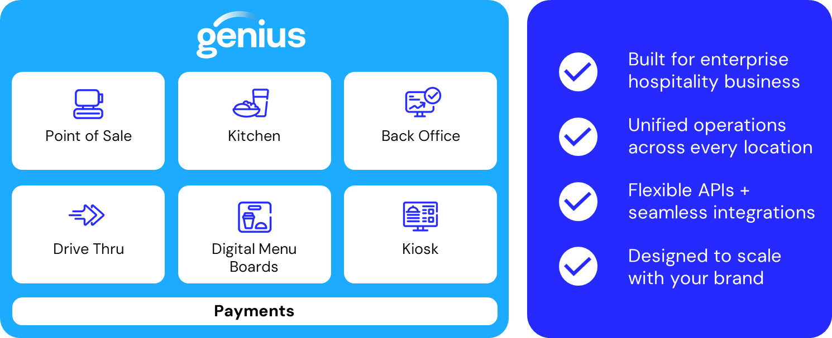
Genius also directly drives revenue growth and customer engagement by expanding payment flexibility and enabling modern commerce experiences. Businesses can accept all major payment types—including contactless, mobile wallets, and gift cards—ensuring they meet evolving customer preferences, while features like loyalty and marketing integrations help increase repeat business. At the same time, next-day funding and flexible pricing options improve cash flow, and can help offset processing costs, delivering measurable financial benefits.
Finally, the platform is designed to scale and support long-term business success with enterprise-grade security, flexibility, and service. PCI-compliant infrastructure with encryption and tokenization protects sensitive payment data, while the cloud-based architecture enables real-time visibility and management from anywhere. Whether adding new devices, locations, or channels, Genius adapts to evolving needs, supported by tailored onboarding and 24/7 expert assistance. The result is a future-ready commerce foundation that reduces risk, improves efficiency, and empowers sustained growth.
Revenue Potential of Genius
The full Genius solution boosts revenue by removing friction across the entire buying and selling experience—making it easier for customers to spend more, and for businesses to capture every sale.
1. Capture more sales across every channel
Genius enables businesses to sell in-store, online, and on the go within a single platform, ensuring no missed revenue opportunities regardless of where customers prefer to shop. By supporting all major payment types, including contactless, mobile wallets, and global digital payment methods, it reduces checkout friction and increases conversion rates. When customers can pay quickly and easily with their preferred method, they are more likely to complete purchases and spend more per transaction.
2. Increase average ticket size and repeat business
Marketing, loyalty, and gift card capabilities can help businesses actively drive higher spending and customer retention. Promotions and loyalty incentives encourage upsells and repeat visits, while seamless customer experiences, especially in restaurants and retail, improve satisfaction and lifetime value. Over time, this leads to more frequent transactions and higher average order values, directly contributing to revenue growth.
3. Improve speed, efficiency, and throughput
By streamlining operations, from order entry to payment processing, Genius allows businesses to serve more customers in less time. Faster checkout lines, synchronized front and back of house operations, and mobile POS capabilities help increase transaction volume, especially during peak periods. The ability to take payments anywhere (e.g., kiosks, handheld devices) also helps capture incremental sales that might otherwise be lost due to long wait times or limited checkout capacity.

4. Protect and expand margins
Finally, Genius improves net revenue by optimizing costs and cash flow. Combined with flexible pricing and scalable infrastructure, businesses can grow revenue without proportionally increasing costs, improving overall profitability.
Bottom line: Genius doesn’t just process payments—it actively creates revenue by increasing conversion, boosting customer spend, enabling faster transactions, and improving margins.
Additional Security for your Business
The full Genius solution improves security by embedding enterprise-grade protections directly into every step of the payment and transaction lifecycle—reducing risk while maintaining a seamless customer experience.
1. End-to-end protection of payment data
Genius uses end-to-end encryption and tokenization to secure sensitive cardholder data from the moment of capture through processing. This ensures that payment information is never exposed in readable form, effectively eliminating opportunities for interception or misuse. By replacing raw card data with tokens, businesses minimize their exposure to breaches and significantly reduce the scope of sensitive data stored in their environment.
2. Built-in PCI-compliant infrastructure
The platform is designed to meet PCI-DSS compliance standards, which are the industry benchmark for payment security. This means businesses leveraging Genius benefit from a system that is already aligned with strict regulatory requirements for handling payment data. As a result, organizations reduce their compliance burden, avoid potential penalties, and maintain trust with customers who expect secure transactions.
3. Reduced risk through a unified ecosystem
By consolidating POS, payments, and management tools into a single, integrated platform, Genius eliminates the need for multiple third-party systems, which can introduce vulnerabilities. Fewer integration points mean fewer gaps for potential cyber threats. Additionally, Genius actively blocks third-party access to payment data, creating a more controlled and secure environment compared to fragmented solutions.
4. Secure cloud-based management and monitoring
Because Genius is cloud-based, businesses gain secure, real-time oversight of transactions and operations from anywhere. This centralization improves visibility into suspicious activity, enables faster response to potential threats, and ensures updates and security patches are deployed automatically, keeping the system protected against emerging risks without requiring manual intervention.
Bottom line: Genius improves security not just with individual features, but through a layered, integrated approach—combining encryption, compliance, controlled access, and cloud-based oversight to protect both the business and its customers while enabling confident, secure growth.
Genius POS
Upgrade to a modern, cloud-based point of sale designed for enterprise quick service and fast casual restaurants. With centralized management, real-time data sync, and offline mode, you’ll keep transactions flowing in any environment — and deliver top-notch customer experiences every time.
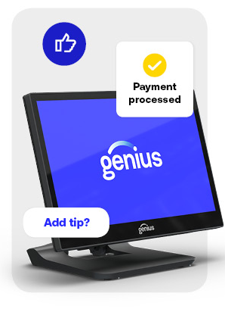
Genius handles high volume without breaking a sweat. Take orders with speed and precision, process payments across every channel and increase the operational efficiency of even the most complex environments.
Compatible with any operating systems - Works on iOS, Android, Windows and Linux, compatible with either GP hardware or customers hardware (rugged terminals and lightweight tablets).
Promotions and discounts — Easily set up and report on discounts and special offers.
Reduce workload for staff – User-friendly dashboards help decrease time spent on routine activities and minimize training effort. The Genius platform provides a single place to access and manage all key tasks.
Data Insights - Use role-based access to control brand, region or store, giving access to data and analytics that help make better business decisions and grow profitability for customers.
Reduce administrative workload – Automates routine employee management tasks, including time clock tracking and staff scheduling.

It's everything a traditional POS offers — and much more. Genius Enterprise POS delivers deep vertical integration with operations and workflows. It’s designed with point-of-sale software functionality that supports centralized management, flexible hardware configurations, and robust APIs to connect with kitchen automation, loyalty programs and enterprise IT systems, making it ideal for high-volume, multi-location businesses.

Genius Cloud POS
Hardware and OS Agnostic
Responsive Design
Genius POS automatically draws the screen based upon the resolution of the device and updated cloud configurations.
Genius Cloud POS can run on any hardware platform and operating system (Windows, Android, iOS) - a claim unique to the product in the QSR industry. This allows for ultimate flexibility in offerings to your operators while being able to run a unified platform across your system.
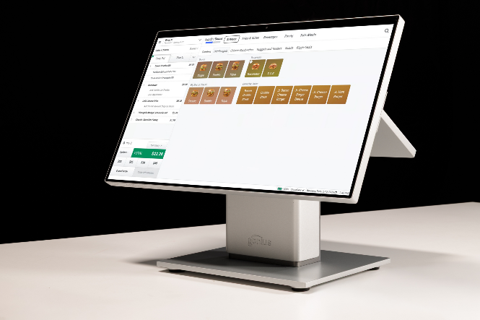
Ease of Deployment
Lower complexity of the Genius POS application implementation reduces the cost and need for highly technical personnel within your organization to roll out across the organization. Operators no longer need to rely on in-store personnel performing register updates to update menu items or prices they can push updates 24/7. Genius POS interacts with the Genius Portal and digital menus seamlessly. This allows for an easy install for new sites, upgrading an existing site to new software, or changing configurations at a site.
No Servers Needed
Thanks to our patented peer-to-peer data sync capabilities, no servers or master terminals are needed at the site. Terminals are in constant communication through UDP to ensure 100% data integrity on site while maintaining cloud connection for backup. This cuts down on costs and eliminates single points of failure.
Ease of Integration
- Our cloud architecture makes integrations more accessible to third parties as Genius leverages microservices that take the burden off the in-store application
- Genius POS has an ever-growing number of existing integrations built on Restful APIs
- The Genius POS modern architecture and programming languages are supported by large software development communities
- Global Payments is eager to create strategic partnerships with companies that can help bring new technologies to our customers across the globe

Genius Back Office

Run a More Profitable Restaurant
More than 10,000 Enterprise QSR locations rely on Genius Back Office (formerly RTIconnect) and Mobile Restaurant Management to cut the fat out of food and labor costs and supersize profits.
Genius offers a different kind of back office that’s easy to use in-store or on the go. Our powerful above store reporting will give you actionable information at your fingertips.

Key features include:
- Cloud-powered, hardware agnostic
- Enterprise-grade
- Role-based task lists help people focus on what’s important
- Access from mobile app or browser
- Powerful food cost and inventory tools help control costs and waste; food
cost variance accurate to the ounce
- Automated scheduling optimizes staffing, saves time, and helps manage
labor costs
- One click to approve and send employee schedules
- Graphical summaries with one-click drill-through give insights at a glance
Back Office with Enterprise Reporting

Run a more profitable restaurant
Inventory, Food Cost Management

Control food costs and waste without the guessing
Labor & Scheduling

Optimize staffing and manage labor costs

Genius Handheld POS
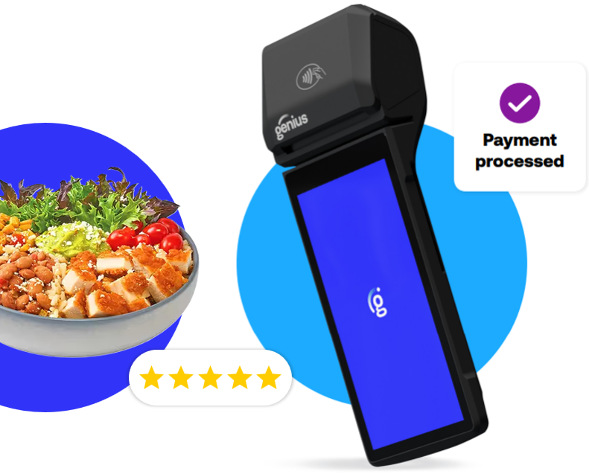
From cashiers to serving staff tableside, the handheld POS supports ordering, menu updates, and waitlist management - providing core POS functions directly in the user’s hand.

Pollo Campero can access store and restaurant tools remotely, allowing you to monitor operations and make updates from any location.
The handheld POS reduces unnecessary steps for servers, enabling you to focus more on guest service and complete tasks more efficiently.
The handheld POS can be deployed easily across new locations, supporting growth without major operational changes.
- Connectivity options (Wi-Fi, 4G/5G cellular, Bluetooth)  - Secure payments  - Suggestive upselling features  - Real-time reporting | - Takeout and delivery order management  - Dynamic discounting features  - Marketing & loyalty programs  - Printed and digital receipts

Genius Kiosk
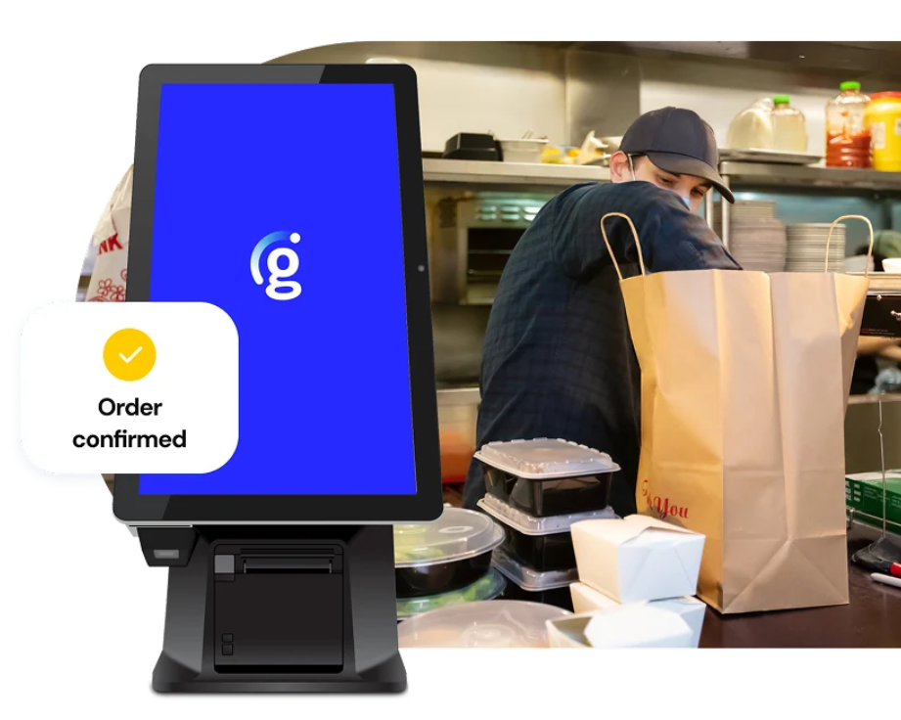
Self-ordering kiosk machines are interactive touchscreen devices that allow customers to place orders without needing to queue up or interact directly with staff.
Genius Kiosk lets guests take control of their experience, offering fast, accurate and personalized ordering designed to handle peak traffic with ease. Reduce wait times, improve order accuracy and alleviate front-of-house pressure — all while increasing bill averages with Genius.
Integrated with a POS system, kiosks streamline the checkout process and make ordering faster and more accurate.

Kiosk hardware options - From compact countertop models to full-sized freestanding units, we can work to ensure your requirements are met.
Unify menus counter to counter - Update menu flows and pricing instantly across Wingstop’s network, so guests know exactly what’s available.
More control, fewer errors - Lets your guests enter their own order exactly how they like it.
Tailored orders - Allows guests to customize their orders, including dietary adjustments, item modifications, and selecting past favorites.
No pressure, no rush - Let guests browse the menu at their own pace — skip the checkout queue and take time choosing.


Genius Kitchen Management
Genius Kitchen, our kitchen management system, offers smart workflows, custom routing, user-friendly kitchen display systems and real-time insights that keep your restaurant operations in sync from front to back of house and across all your locations. Best of all? It’s designed to seamlessly integrate with Genius Enterprise POS.
This is a cloud-based digital platform that streamlines and automates back-of-house operations, centralizing functions for kitchens like order management (including online ordering), recipe control, menu engineering, food prep tracking, labor optimization, inventory tracking and reporting.
- Display orders by prep station, priority or channel
- Role-based screens
- Sync in real time with POS, drive-thru tech and more

 | Recipe management  Recipe management across locations and tracks modifications in real time.
 | Order routing in real time  Dynamically directs incoming orders to the right kitchen stations to balance capacity, minimize delays and maintain smooth operations.
 | Inventory management  Monitors ingredient usage automatically, reducing waste through accurate tracking, and triggers timely reordering to keep kitchens supplied.
 | Load balancing  Distributes workload evenly across multiple preparation stations to prevent bottlenecks and maintain optimal efficiency.

